# Perform Dunning History Search through Dunning History Mashup from C4C

SAP Analytics Cloud (SAC) and SAP Hybris Cloud for Customer (C4C) analytics integration has been tightened further.

If you have an SAC report it can be viewed in C4C as a live report. You can play around with your SAC Story and perform all possible actions within the C4C system. To do this you should setup SAC report as a mash-up in C4C.

Once you have the correct URL create a HTML Mash up in C4C. This can be done in Administrator Work Center – > Business Flexibility -> Mashup Authoring

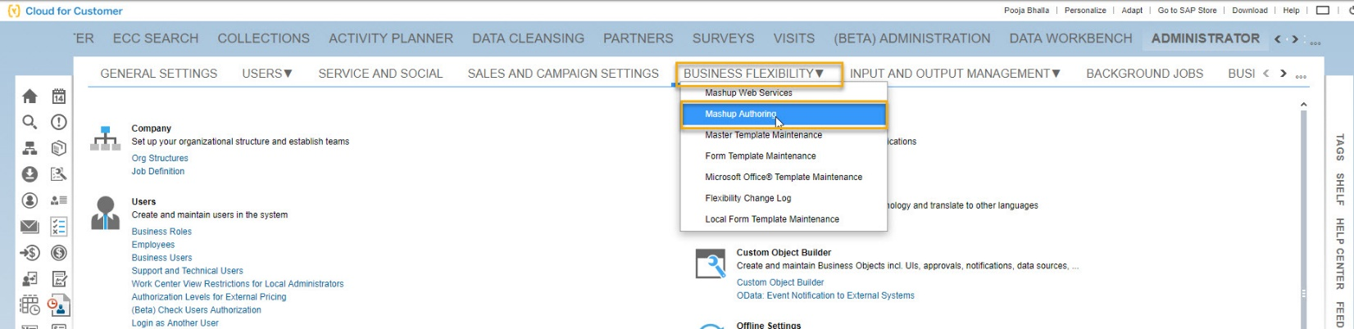

Create an HTML mash-up

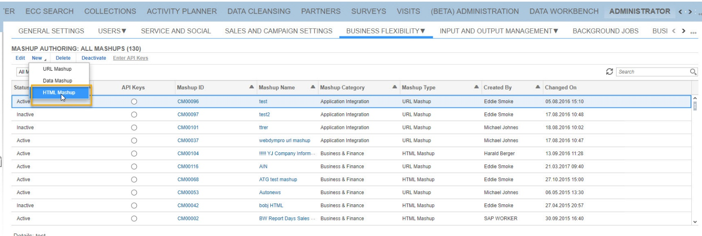

Select Mash-up category and port binding based on your scenario.

The example **scenario** that I am taking here is – I manage a large account called Globex. We get business form multiple Globex subsidiary. When I am going to meet the customer, I would like to have a visibility on all the business we get from each of its subsidiary, what work we completed and what is the Pipeline of opportunities. The data for this report is coming from multiple systems.

Invoice Data – S/4 HANA

Work completion details – S/4 HANA

Pipeline – C4C  
I created a story in C4C that filters on this account and pulls data from both S/4 HANA as well as C4C. Since this story is relevant for Account Object I selected Port Binding as ‘Additional Account Information’.

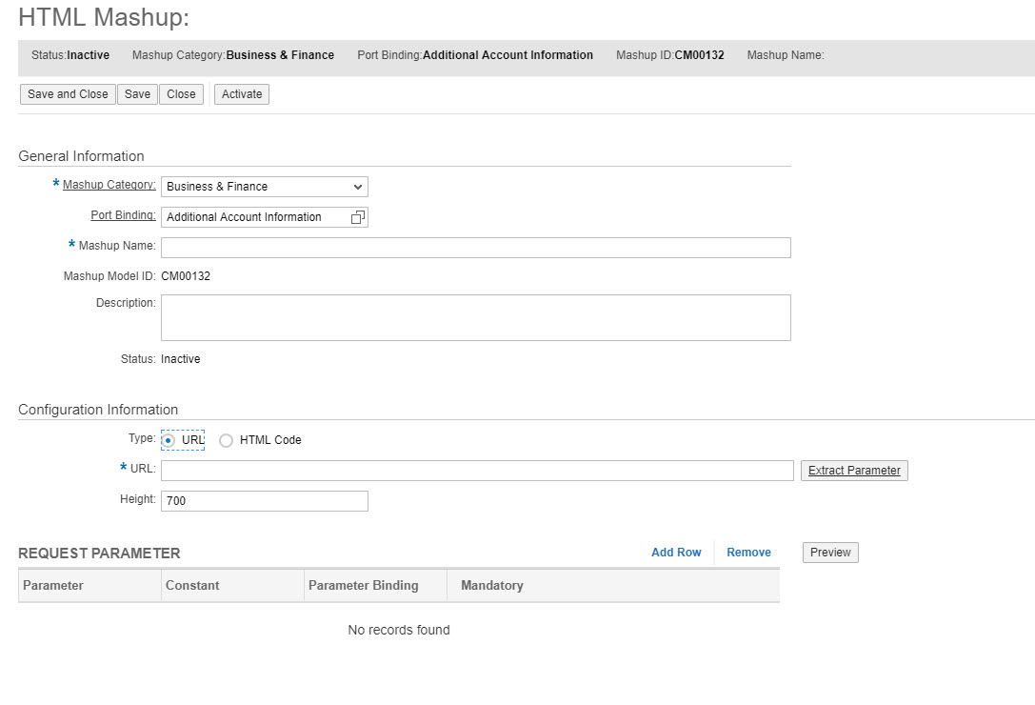

The Story has multiple reports thus I will need more space to show the data. That’s why the mashup width has been increased to 700.

Now add the URL that we created in step 1 and extract the parameters:

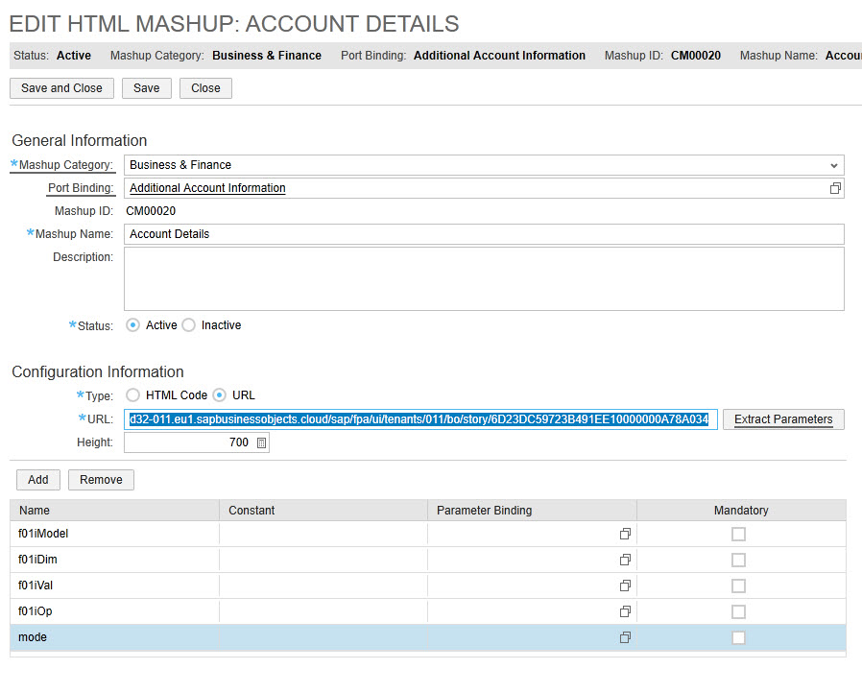

When you extract the parameters by default each one will have a ‘$’ sign in between. Change this to 1. And add the parameters as below:

f01iModel -> Model ID:Model ID

f01iDim -> Dimension ID

*\*Note Model ID and Dimension ID are SAC model ID and SAC story filter dimension ID*

Since we want the Mash-up in C4C to show contextual data we will pass the values from the screen.

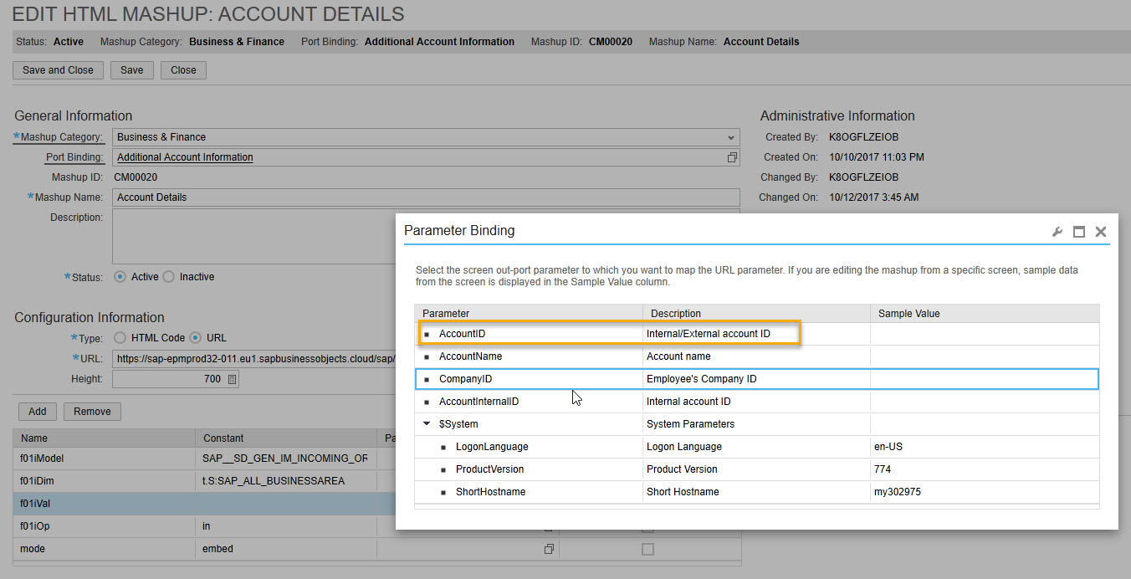

Set f01iOP and mode based on your requirement. Please refer to the blog below to understand the meaning of these parameters

Once the mash-up is saved it will be available to be added in the Account object.

Add the mash-up in the appropriate Tab of Account Object. This can be done by an Admin in Adapt mode. Click Adapt->Edit Master Layout and make the mash-up visible.

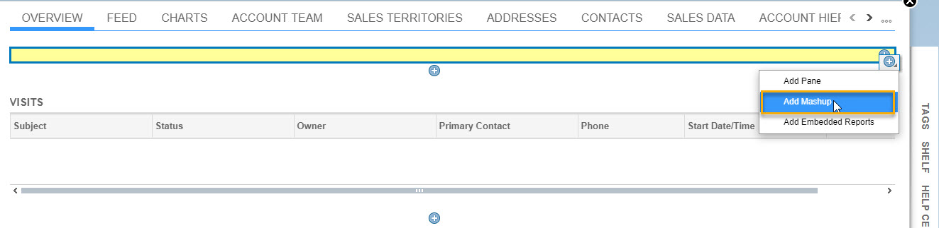

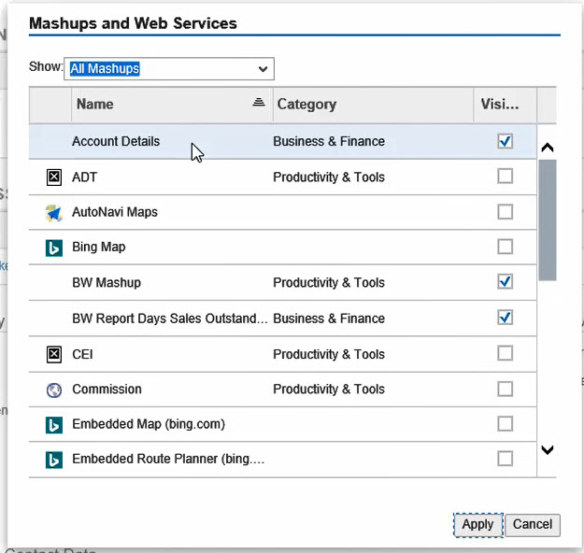

This will enable the end user to analyze the data contextually when he/she is reviewing the account details.

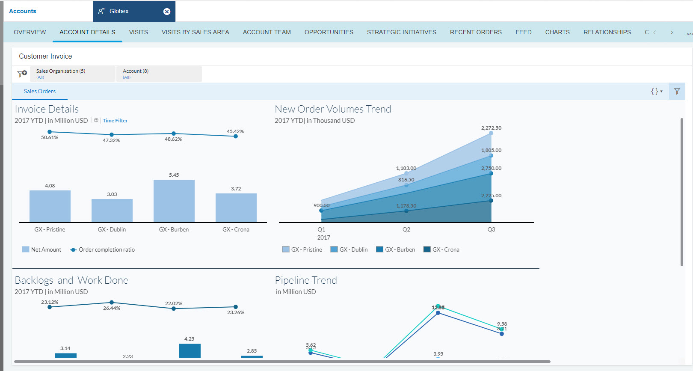

Functions in the Dunning History

#### Use

The system records all dunning data for each dunned item in a dunning history. There you can find out about the individual dunning steps. The dunning program uses the dunning history to determine the dunning levels.

#### Features

In the dunning history, you can see which items have been dunned for a particular area. The functions of the dunning history are protected by the following authorization objects:

* F_KKDU (Dunning in Contract Accounts Receivable and Payable)
* F_KKKO_BUK (Authorization in Company code)
* F_KKKO_GSB (Authorization in Business Area)
* F_KKKO_BEG (Authorization for Account via Authorization Group of Contract Account)

The dunning header contains the field content for the company code and business area that is required for the check. The contract account in the dunning header determines the authorization group. If no contract account is specified in the dunning header (cross-contract account dunning), the system does not check the authorization group. The system issues a message informing you of how many dunning notices are not displayed due to missing authorizations. Using the authorization object F_KKDU, the system checks the dunning history for authorization for the activities Set Next Dunning Level and Reverse Dunning Notice .